Data Structures and Algorithm using Python
Program 1:

Aim:

Write Python Program to Perform Recursion operation to find factorial for given integers.

Algorithm:

Step 1: Start

Step 2: Define a function factorial(x)

Step 3: Inside the function, check if x == 0 or x == 1

Step 4: If true, return 1

Step 5: Otherwise, return x * factorial(x − 1)

Step 6: Read an integer value from the user and store it in num

Step 7: Check if num < 0

Step 8: If num < 0, print “Factorial is not defined for negative numbers”

Step 9: Else, call factorial(num) and store the returned value

Step 10: Print“The factorial of num is result”

Step 11: Stop

Program:

def factorial(x):
"""This is a recursive function to find the factorial of an integer"""
if x == 0 or x == 1:
return 1
else:
return x * factorial (x - 1)

# Taking input from user at runtime
num = int(input("Enter a number: "))

if num < 0:
print("Factorial is not defined for negative numbers")
else:
print("The factorial of", num, "is", factorial(num))

Output:

Enter a number: 5

The factorial of 5 is 120

Result:

The Python program to perform recursion to find the factorial of a given integer was successfully executed.
-----------------------------------------------------------------------------------------------
Program 2:

Aim:
Write Python Program to Perform Linear Search using Recursion to find the element is found or not and its position.

Algorithm:

Step 1: Start

Step 2: Read list elements from the user and store them in list L1

Step 3: Read the element to be searched and store it in x

Step 4: Initialize pointer i = 0

Step 5: Repeat while i < len(L1)
Step 5.1: If L1[i] == x, then
Print “Element x present at ith position”
Exit the loop

Step 5.2: Otherwise, increment i by 1

Step 6: After the loop, check if i >= len(L1)

Step 7: If true, print “Element is not present”

Step 8: Stop

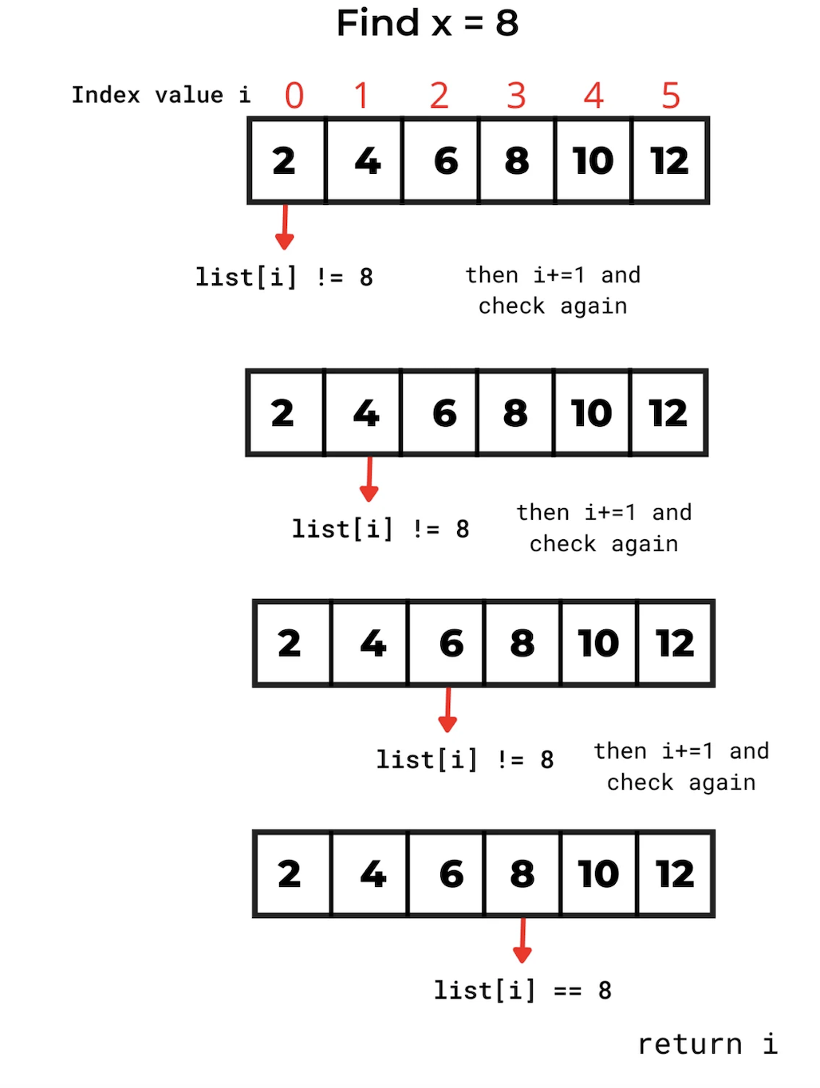

Program:

# Taking list input from user
L1 = list(map(int, input("Enter list elements separated by space: ").split()))

# Taking element to search
x = int(input("Enter element to search: "))

i = 0 # pointer

while i < len(L1):
if L1[i] == x:
print(f'Element {x} present at {i}th position')
break
i += 1

if i >= len(L1):
print('Element is not present')

Output:

Enter list elements separated by space: 2 10 30 40 50

Enter element to search: 30

Element 30 present at 2th position

Result:

The Python program to perform linear search using recursion to determine whether an element is found and to display its position was successfully executed.

-----------------------------------------------------------------------------------------------

Program 3:

Aim:

Write Python Program to Perform Linear Search using Recursion to display the element in the array and find the element using its index.

Algorithm:

Step 1: Start

Step 2: Define a function linear_search(L, key, i)

Step 3: Inside the function, check if i ≥ length of L

Step 4: If true, return -1 (element not found)

Step 5: Check if L[i] == key

Step 6: If true, return i (index of the found element)

Step 7: Otherwise, call
linear_search(L, key, i + 1)

Step 8: Read list elements from the user and store them in list L

Step 9: Read the element to be searched and store it in key

Step 10: Call x = linear_search(L, key, 0)

Step 11: If x ≠ -1, then
Print the list L
Print “Element key is available at index x”

Step 12: Else, print “The element is not present”

Step 13: Stop

Program:

def linear_search (L, key, i):
if i >= len(L):
return -1
if L[i] == key:
return i
return linear_search(L, key, i + 1)

# Taking list input at runtime
L = list(map(int, input("Enter list elements separated by space: ").split()))

# Taking key input
key = int(input("Enter element to search: "))

x = linear_search(L, key, 0)

if x != -1:
print('List :', L)
print(f'Element {key} is available at index : {x}')
else:
print('The element is not present')

Output:

Enter list elements separated by space: 10 20 30 40 50 60

Enter element to search: 60

List : [10, 20, 30, 40, 50, 60]

Element 60 is available at index : 5

Result:

The Python program to perform linear search using recursion was successfully executed, and the element was found at the correct index.

------------------------------------------------------------------------------------------------

Program 4:

Aim:

Write Python Program to Perform Binary Search using Recursion using an array to find the position of an element in an index.

Algorithm:

Step 1: Start

Step 2: Define a function binary_search(arr, low, high, x)

Step 3: Check if high ≥ low

Step 4: If true, calculate the middle index mid = (low + high) // 2

Step 5: Compare arr[mid] with x

Step 5.1: If arr[mid] == x, return mid
Step 5.2: Else if arr[mid] > x, call binary_search(arr, low, mid − 1, x)

Step 5.3: Else, call binary_search(arr, mid + 1, high, x)

Step 6: If high < low, return -1 (element not present)

Step 7: Read sorted array elements from the user and store in array arr

Step 8: Read the element to be searched and store it in x

Step 9: Call result = binary_search(arr, 0, length of arr − 1, x)

Step 10: If result ≠ -1, print “Element x is present at index result”

Step 11: Else, print “Element is not present in array”

Step 12: Stop

Program:

# Returns index of x in arr if present, else -1
def binary_search(arr, low, high, x):

# Check base case
if high >= low:
mid = (high + low) // 2

# If element is present at the middle itself
if arr[mid] == x:
return mid

# If element is smaller than mid, search left subarray
elif arr[mid] > x:
return binary_search(arr, low, mid - 1, x)

# Else search right subarray
else:
return binary_search(arr, mid + 1, high, x)
else:
return -1

# Taking sorted array input at runtime
arr = list(map(int, input("Enter sorted array elements separated by space: ").split()))

# Taking element to search
x = int(input("Enter element to search: "))

# Function call
result = binary_search(arr, 0, len(arr) - 1, x)

if result != -1:
print(f"Element {x} is present at index {result}")
else:
print("Element is not present in array")

Output:

Enter sorted array elements separated by space: 10 20 30 40 50 60 70

Enter element to search: 50

Element 50 is present at index 4

Result:

The Python program to perform binary search using recursion on an array to find the position of an element was successfully executed.

-----------------------------------------------------------------------------------------------

Program 5:

Aim:

Write Python Program to Perform Binary Search using Recursion to display the element in the array and find the element using its index.

Algorithm:

Step 1: Start

Step 2: Define a function binary_search(L, key, low, high)

Step 3: Check if high ≥ low

Step 4: Calculate the middle index mid = (low + high) // 2

Step 5: Compare key with L[mid]

Step 5.1: If key == L[mid], return mid

Step 5.2: Else if key > L[mid],call binary_search(L, key, mid + 1, high)

Step 5.3: Else,call binary_search(L, key, low, mid − 1)

Step 6: If high < low, return -1 (element not present)

Step 7: Read sorted list elements from the user and store them in list L

Step 8: Read the element to be searched and store it in key

Step 9: Call idx = binary_search(L, key, 0, length of L − 1)

Step 10: If idx ≠ -1, print “In list L, the key key lies at index idx”

Step 11: Else, print “The element is not present in array”

Step 12: Stop

Program:

def binary_search(L, key, low, high):
if high >= low:
mid = (low + high) // 2
if key == L[mid]:
return mid
elif key > L[mid]:
return binary_search(L, key, mid + 1, high)
else:
return binary_search(L, key, low, mid - 1)
else:
return -1

# Taking sorted list input at runtime
L = list(map(int, input("Enter sorted list elements separated by space: ").split()))

# Taking key input
key = int(input("Enter element to search: "))

# Function call
idx = binary_search(L, key, 0, len(L) - 1)

if idx != -1:
print(f'In list {L}, the key {key} lies at index : {idx}')
else:
print('The element is not present in array')

Output:

Enter sorted list elements separated by space: 11 22 33 44 55 66 77 88

Enter element to search: 44

In list [11, 22, 33, 44, 55, 66, 77, 88], the key 44 lies at index : 3

Result:

The Python program to perform binary search using recursion successfully displayed the element in the array and found its index.

----------------------------------------------------------------------------------------------

Program 6:

Aim:
Write Python Program to Perform Stack operation to print in reverse sort.

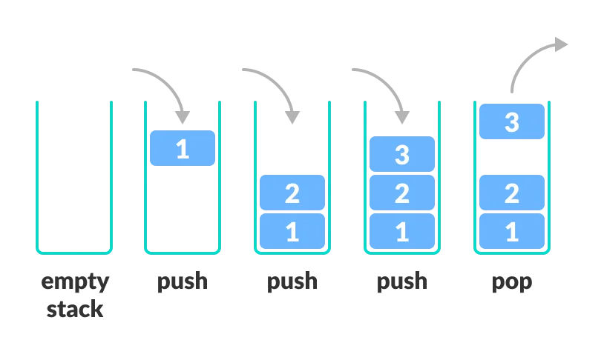
Algorithm:

Step 1: Start

Step 2: Initialize an empty list stack

Step 3: Read an integer value from the user and store it in n
(number of elements to push into the stack)

Step 4: Repeat for i = 1 to n

Step 4.1: Read an element from the user

Step 4.2: Push the element into the stack using append()

Step 5: Display the initial stack

Step 6: Display the message “Elements popped from stack”

Step 7: Repeat while the stack is not empty

Step 7.1: Pop the top element from the stack using pop()

Step 7.2: Display the popped element

Step 8: Display the stack after all elements are popped

Step 9: Stop

Program:

# Stack implementation using list
stack = []

# Taking number of elements from user
n = int (input ("Enter number of elements to push into stack: "))

# Push operation
for i in range(n):
element = input(f"Enter element {i+1}: ")
stack.append(element)

print("\nInitial stack")
print(stack)

# Pop operation
print("\nElements popped from stack:")
while stack:
print(stack.pop())

print("\nStack after elements is popped:")
print(stack)

Output:

Enter number of elements to push into stack: 5
Enter element 1: 10
Enter element 2: 20
Enter element 3: 30
Enter element 4: 40
Enter element 5: 50

Initial stack
['10', '20', '30', '40', '50']

Elements popped from stack:
50
40
30
20
10

Stack after elements is popped: []

Result:

The stack operations were performed successfully and the elements were printed in reverse sorted order using stack (LIFO) principle

------------------------------------------------------------------------------------------------

